OS LAB 6 Task

The .c file of all the codes is uploaded on GitHub, Check Code

Q1:

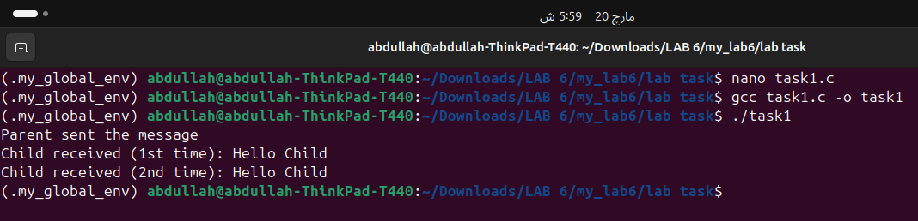

Q2:
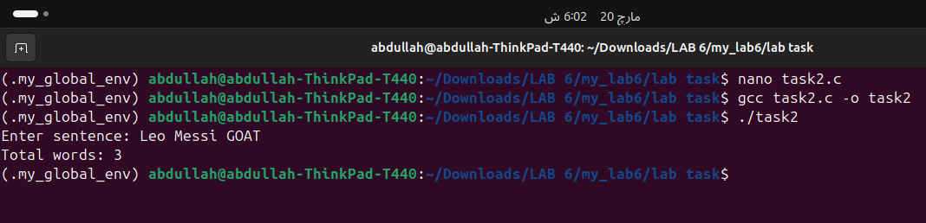

Q3:
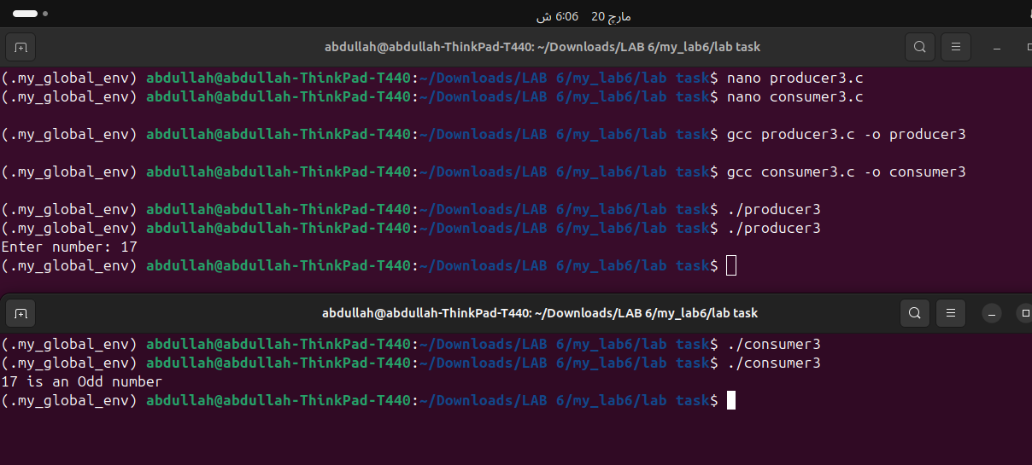

Q4:
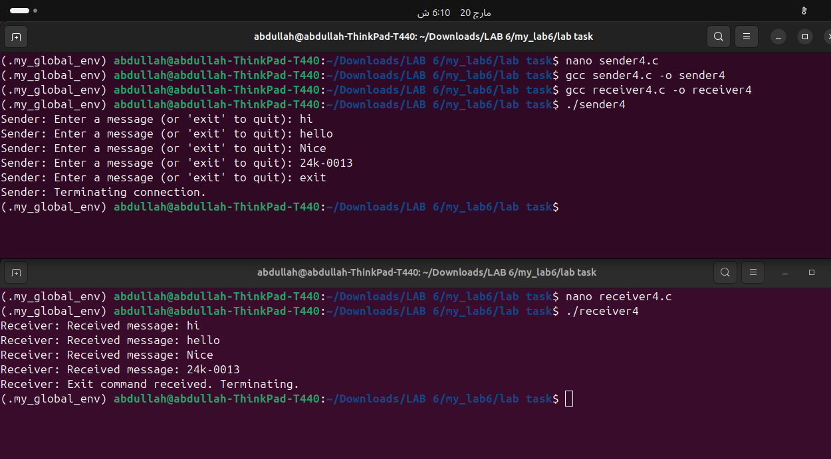

Q5:
